Michelle Nicolle Quartet 2023

Geoff Hughes (guitar)

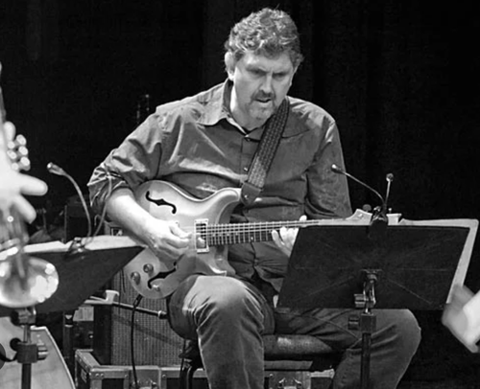

Originally from Wellington, New Zealand, Geoff is a highly accomplished musician. His practical knowledge of harmony and time is rare and much sought after - honing his craft whilst living and working throughout Europe in the 1980’s.

During this time Geoff's gigs included The North Holland Philharmonic, and supporting jazz greats Michael Brecker, Dave Liebman, and Herb Ellis.

Since moving to Australia he’s recorded a CD “The Drop” with Allan Browne, and brought his unique sound to the bands of Joe Chindamo and Christine Sullivan. He often plays sessions with the Melbourne Symphony Orchestra, and touring shows such as The Main Event.

Geoff was a core member of teaching staff at the Victorian College of the Arts for 20 years, and in 2007 he completed his Masters in Music Performance at The University of Melbourne.

Tom Lee (double bass)

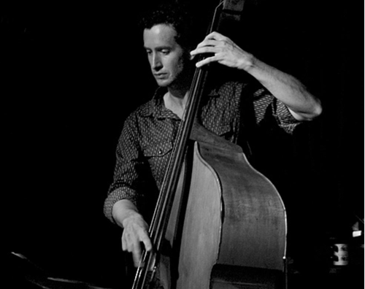
Tom Lee completed the Bachelor of Music Performance at the VCA in 2002. While at the VCA he studied under bassists Geoff Kluke, Ben Robertson as well as Assistant Principal bassist for the MSO, Andrew Moon. He has also studied at the School of Improvised Music, located in New York, under bassist Drew Gress.
Tom has recorded with ensembles such as Vada, the Gian Slater Project, Contrabanda and Cannonball.

He has performed at numerous festivals including the WOMADELAIDE, Wangaratta International, & the Melbourne International Jazz Festival.

Ronny Ferella (drums)
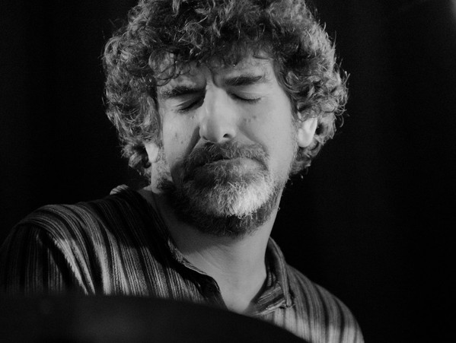
Ferella’s own band IshIsh, for which he composed most of the material, made quite an impact on the Australian scene - releasing four CDs. In July 2001 IshIsh performed at the prestigious Umbria Jazz Festival in Italy, and Pori Festival (Finland).
Ferella leads other original improvised-based bands including Mandala, Omelette and in 2009 launched a CD label and website, Downstream Music which promotes improvised music made in Melbourne. In 1997 he was a finalist in National Jazz Award Drum Competition. In 2019 he founded a musician-based organisation, Small Space Music, involved in presenting concerts and he lectures in Small Ensemble, Improvisation, Freeplay and drums at University of Melbourne.

