Michelle Nicolle Brief Biog 2023 www.michellenicolle.com
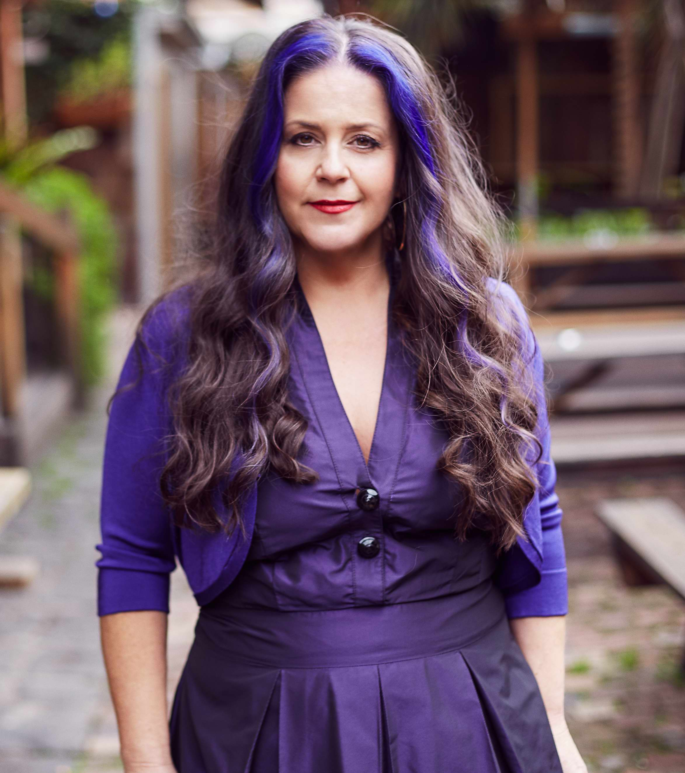
Instagram

Bell Award (2017), Mo Award 2001, 2003 & 2004, National Jazz Award (1998) winner and A.R.I.A Finalist 2001, 2004, 2009 Michelle Nicolle is a jazz musician whose chosen instrument is Voice. Also an arranger and band-leader, Michelle started her musical career at the age of eight, studying the violin in the famous wine region, Barossa Valley. Now based in Melbourne, she is celebrated as Australia's finest female jazz singer.

Known for her ability to get right to the heart of a song, as well as being an in the moment improviser Michelle has continually developed and nurtured her art form with the help of her quartet. As well as releasing 8 CDs the MNQuartet has toured extensively throughout Australia and internationally, with performances including Tokyo Jazz Festival, Jakjazz(Indonesia),Jarasum Jazz Festival (Korea), Turkey, Estonia, Finland, North Sea Jazz Festival (Netherlands),Asia Pacific Festival (Russia), Prague Jazz Festival (Cz Republic), Trinity Laban, London and JEN Conference, 2017,2020, 2023 Frost School of Music (Miami) and JazzVox in Seattle 2017, 2019, 2023, University Of North Texas 2019, Oceanside Jazz Festival, Sidebar, (New Orleans), G Spot, Kulak’s Woodshed 2023(LA), Classic Pianos, (Portland, OR) 2020, Jazz Lounge Live (San Diego 2023) The Blue Building (NYC 2023).

Apart from her 24years together quartet, Michelle has held a 15 year residency at The Brunswick Green, where she and various musical friends play audience requests all night. Her other projects include What Reason Trio (with guitarist Stephen Magnusson) and MN Frettet (featuring 4 guitarists), as well as working as a free-lance vocalist for various recording session work.

Michelle holds a Bachelor of Education, an Associate Diploma of Jazz (University of Adelaide) and currently teaches voice, improvisation and Small Jazz Ensemble at University of Melbourne, VCASS (Victorian College of the Arts Secondary School), Monash University, and regularly tours Australia and USA as a clinician: Cal.State University Northridge, CS University Long Beach, 2023, University of North Texas 2019, University of Miami 2018).

"Michelle is a singer born to sing, born to charm, enlighten and seduce through music. I only wish she lived in the States somewhere so I could manage to hear her more often.” Kurt Elling
"..an exceptional singer... who deserves attention as an original and inspiring Jazz artist." Cadence Magazine (USA)
“ an Australian jazz singer ready to command a world stage.” Sydney Morning Herald

"....Michelle impressed from the start with her talents, not only is a vocalist with a very wide octave range but also as an excellent improviser." Bangkok Post

“Nicolle’s warmth and an effortless flow of ideas makes the old sound new. This is a voice Australia should be proud of. 4.5 Stars” Limelight Magazine

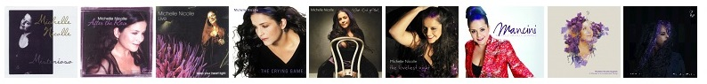____________________________________________________________________________________
Michelle Nicolle Quartet: Geoff Hughes (guitar), Ronny Ferella (drums), Tom Lee (bass)
For more info: www.michellenicolle.com
YouTube Channel

