Michelle Nicolle 2023
www.michellenicolle.com
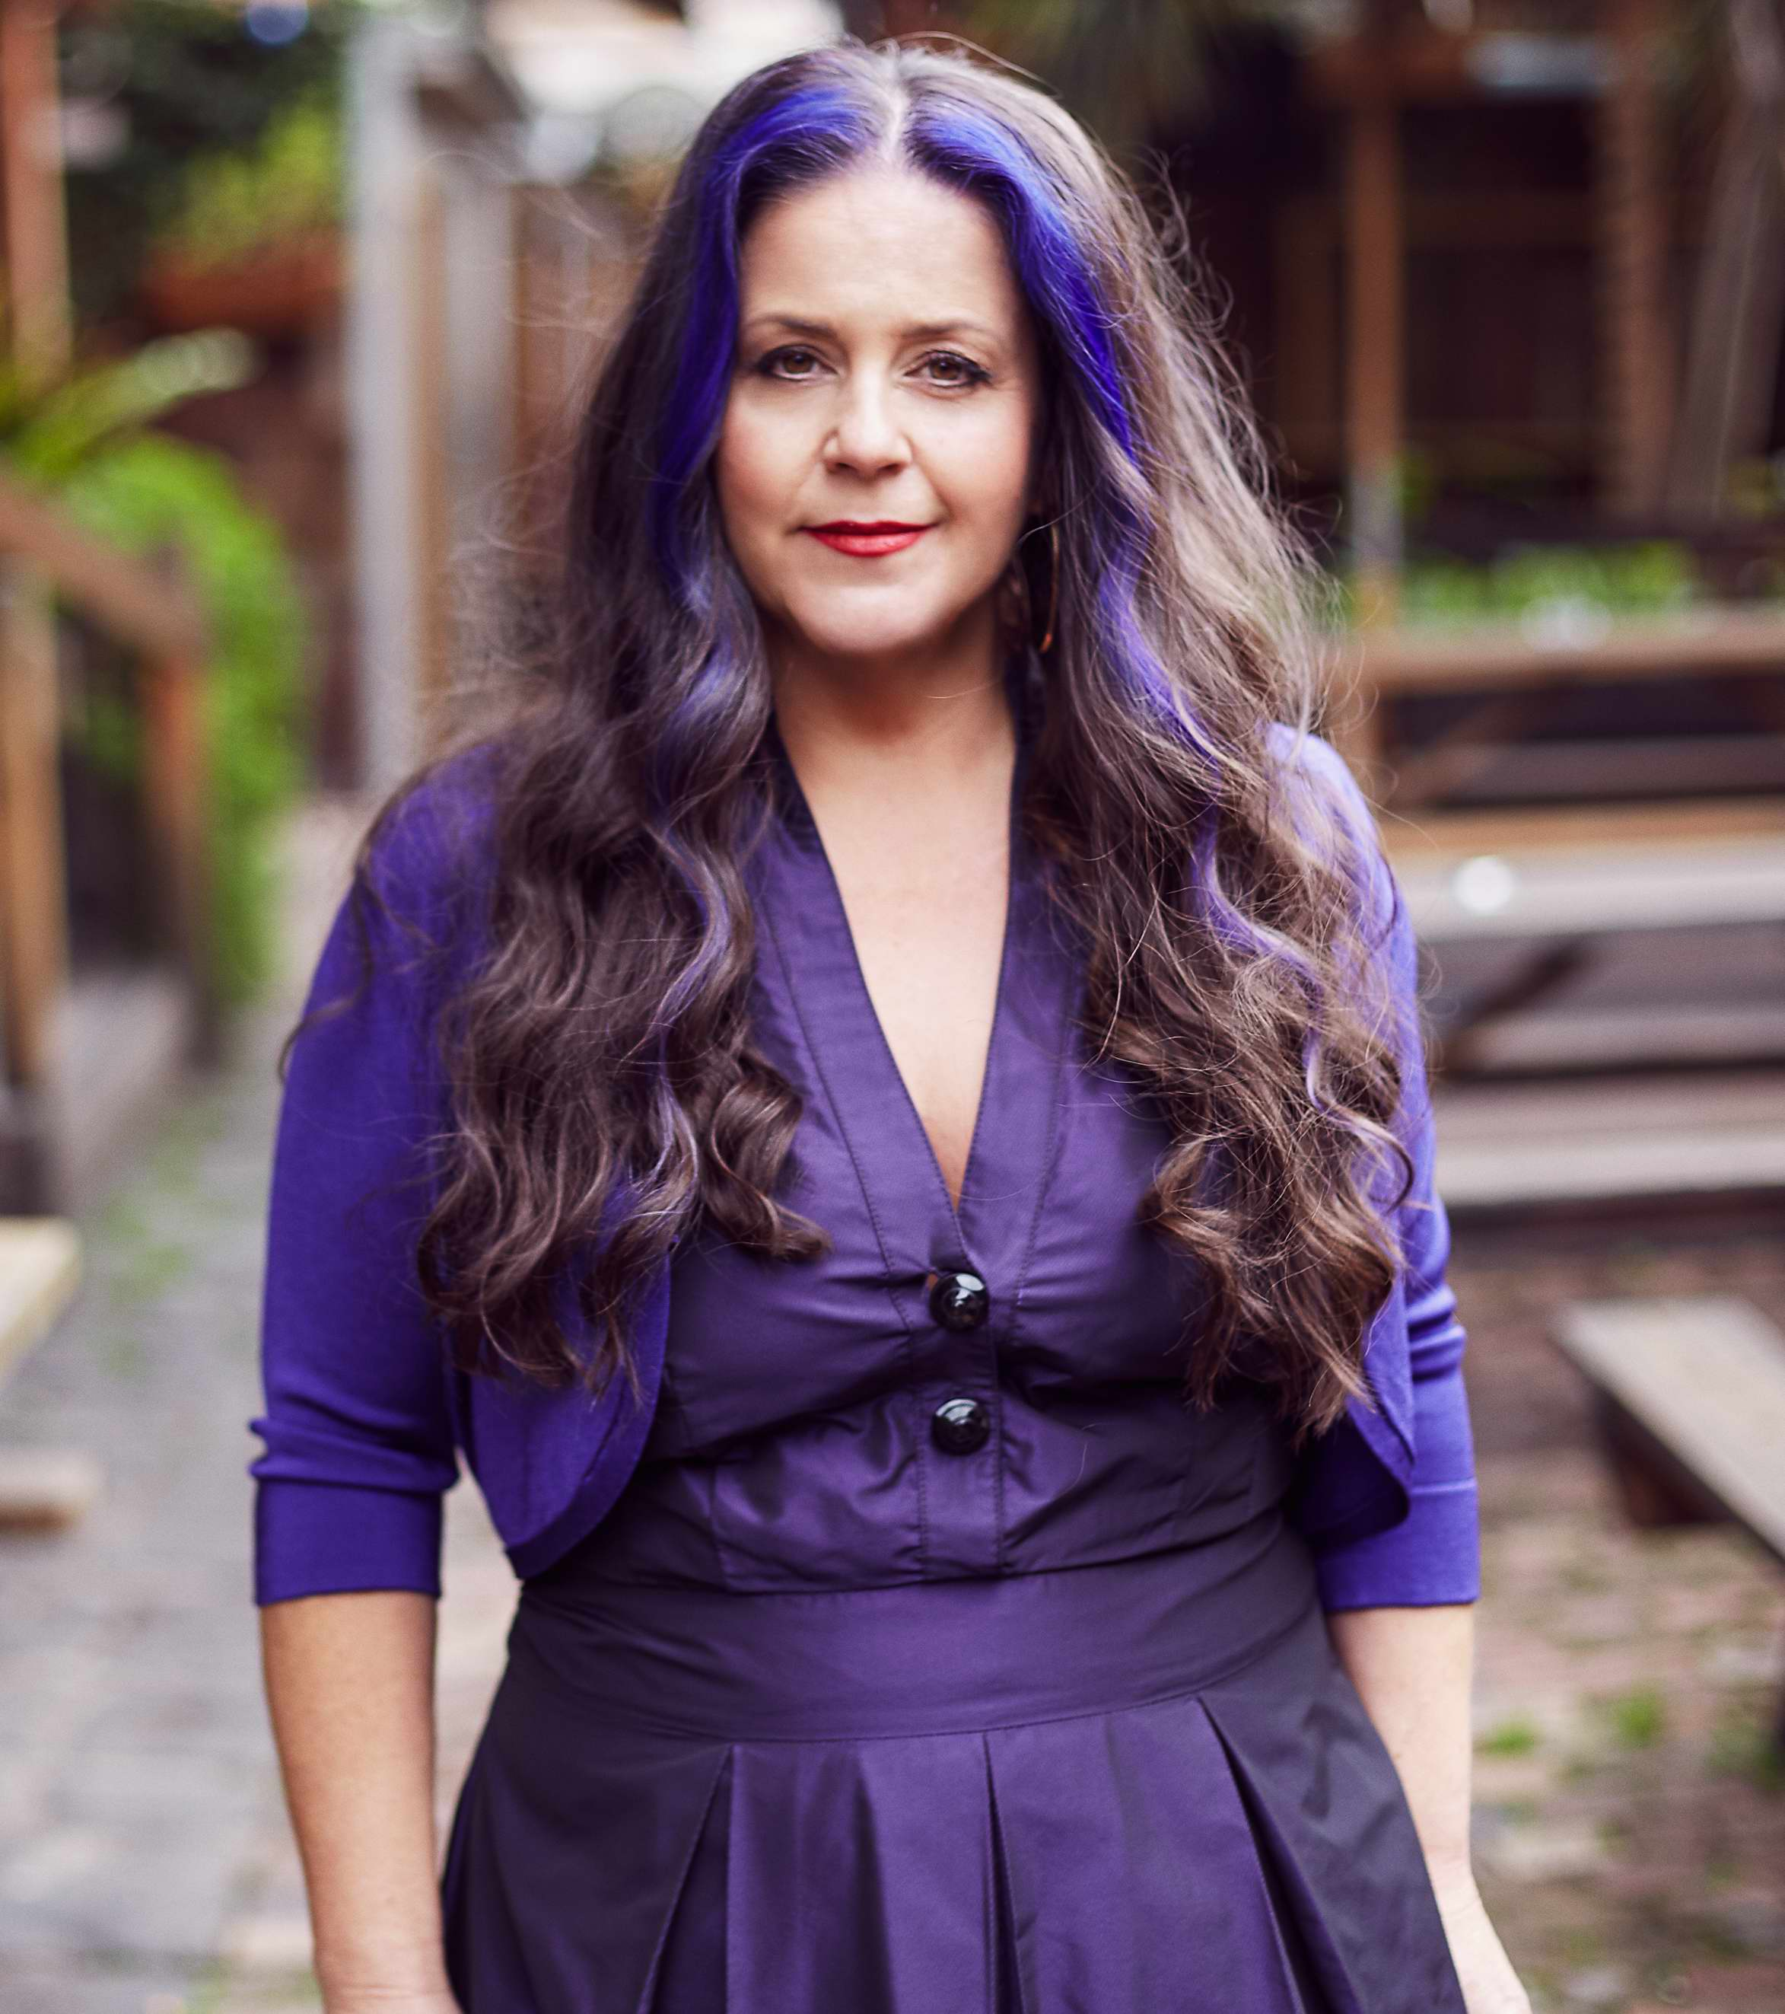
Instagram

Bell Award (2017), Mo Award 2001, 2003 & 2004, National Jazz Award (1998) winner and A.R.I.A Finalist 2001, 2004, 2009 Michelle Nicolle is a jazz musician whose chosen instrument is Voice. An arranger and band-leader, Michelle started her musical career at the age of eight, studying the violin in the famous wine region, Barossa Valley. Now based in Melbourne, she is celebrated as one of Australia's finest female jazz singers.

Known for her ability to get right to the heart of a song, as well as being an in the moment improviser Michelle has continually developed and nurtured her art form with the help of her quartet: Geoff Hughes (g), Tom Lee (b) and Ronny Ferella (d). Regarded as one of this country’s finest jazz & improvising ensembles, the Michelle Nicolle Quartet are celebrating their 24th year together.

“..all the band had to do was set up a golden glow of warmth, soft groove and space and Nicolle was soaring to places you will be taken by few singers. In the world, I mean.” Sydney Morning Herald, 2016

As well as releasing 9 CDs they’ve toured extensively throughout Australia and internationally, with performances including Tokyo Jazz Festival, Jakjazz(Indonesia),Jarasum Jazz Festival (Korea), Turkey, Estonia, Finland, North Sea Jazz Festival (Netherlands),Asia Pacific Festival (Russia), Prague Jazz Festival 2015, 2018 (Cz Republic), London 2016 and JEN Conference, New Orleans 2017,2020, Frost School of Music (Miami) and JazzVox in Seattle, (USA) 2017, 2019, University Of North Texas 2019, Oceanside Jazz Festival (Mira Costa, USA) 2019, and Sidebar, (New Orleans), G Spot, (Los Angeles), Classic Pianos, (Portland, OR) 2020, The Blue Building (NYC 2023).

Over this ongoing period of musical activity, the MNQ has developed a double identity;
It is a jazz ensemble steeped in tradition - playing original compositions by Michelle, interpreting and reimagining the great American Songbook and a 21st Century improvising chamber group- where each member has a highly developed sense of the musical possibilities that the collective can achieve in any moment.

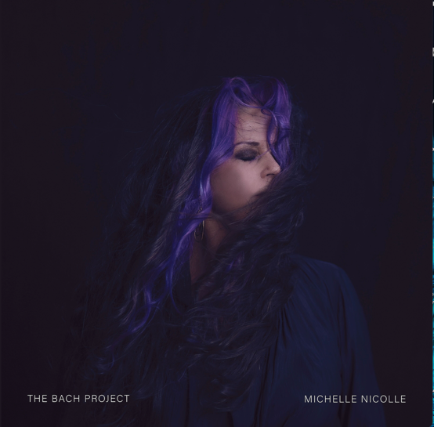
It is the melding of these two identities that the MNQ use to tackle the challenge of The Bach Project. The majesty and formal brilliance of Bach’s music is taken on a journey which creates a completely new sonic outcome, but the song remains the same. At the heart of it, Bach was a composer with an improvisors spirit and in the hands of the Michelle Nicolle Quartet his music is reimagined with this spirit once more.

MNQ has just released their 9th CD release, The Bach Project.

Apart from Quartet, Michelle has held a 15 year residency at Melbourne’s The Brunswick Green, where she and various musical friends play audience requests every Thursday night. Her other projects include What Reason Trio (with guitarist Stephen Magnusson) and MN Frettet (featuring 4 guitarists), as well as working as a free-lance vocalist for various recording session work.

Michelle holds a Bachelor of Education, an Associate Diploma of Jazz (University of Adelaide) and currently teaches at University of Melbourne, Victorian College of the Arts Secondary School, and Monash University. Since 1998 she has conducted Masterclasses and Workshops all over Australia, and in Singapore, Taiwan and at Trinity Laban Conservatoire of Music (London), JEN Conference (New Orleans 2017, 2020, 2023), Frost School of Music (University of Miami 2017), University of North Texas 2019, Oceanside Jazz Festival 2019 (Mira Costa, USA), International Jazz Voice Conference 2015 2019 (Finland).
As an educator, Michelle advocates for the vocalist as an equally respected and valued musical member of the jazz ensemble. Her philosophy that has developed as a performer of 30+ years is that fluency in improvising comes from strength in musical independence. Michelle teaches her students about security in the form, time, melody, pitch and harmony – all whilst supporting the story of the song. Having independence as a vocalist, relying on no other member of an ensemble, allows freedom and confidence in hearing and expressing the musical landscape as well as any instrumentalist.

"Michelle is a singer born to sing, born to charm, enlighten and seduce through music. I only wish she lived in the States somewhere so I could manage to hear her more often.” Kurt Elling
"..an exceptional singer... who deserves attention as an original and inspiring Jazz artist." Cadence Magazine (USA)
“ an Australian jazz singer ready to command a world stage.” Sydney Morning Herald

"....Michelle impressed from the start with her talents, not only is a vocalist with a very wide octave range but also as an excellent improviser." Bangkok Post

“Sometimes dreamy, sometimes as excited as a child in a sweet shop, but always marvellously expressive, Michelle Nicolle is a jazz singer of singular talent.” Nova

“Nicolle’s warmth and an effortless flow of ideas makes the old sound new. This is a voice Australia should be proud of. 4.5 Stars” Limelight Magazine

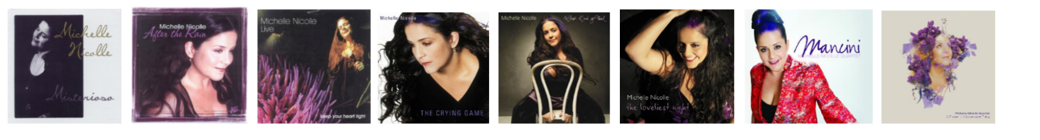____________________________________________________________________________________
Michelle Nicolle Quartet: Geoff Hughes (guitar), Ronny Ferella (drums), Tom Lee (bass)
For more info: www.michellenicolle.com
Instagram
Facebook
Spotify

